Arrival Details for Dummy Entry

Purchase order entry:

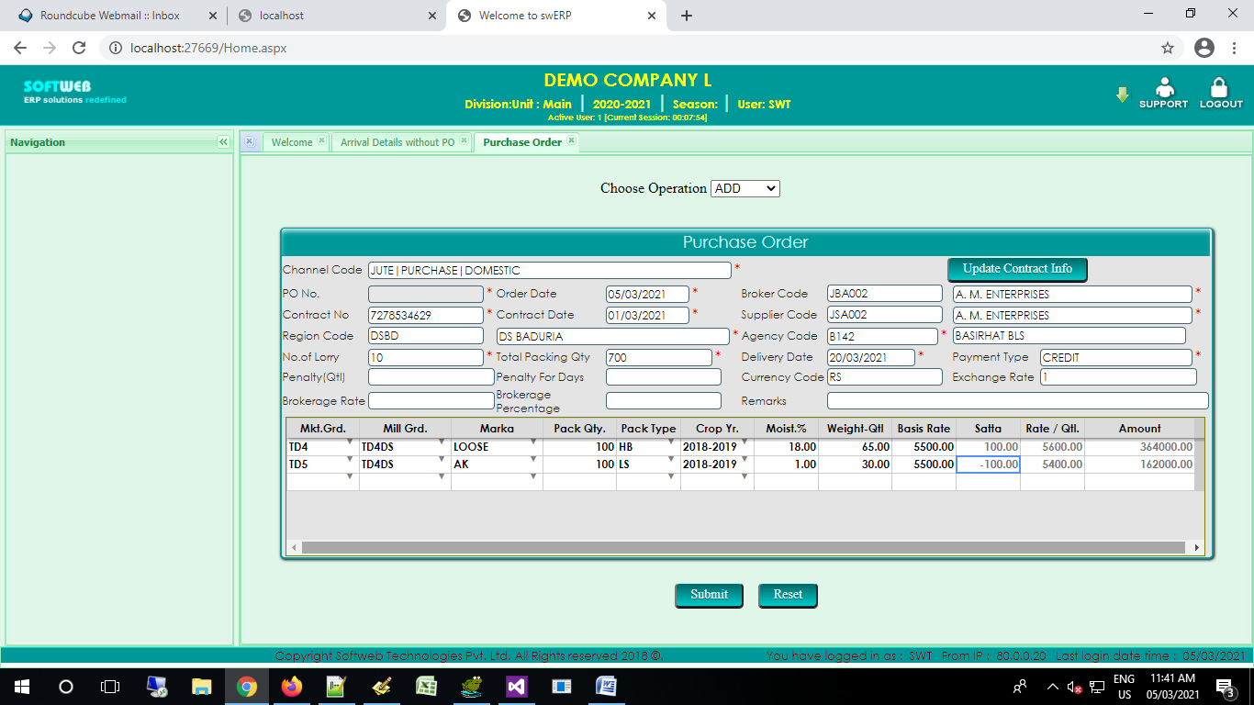

#SUCCESS#ORDER NUMBER : L/JPO/21/00118 DATED : 05-MAR-21

fields to be changed/validate as per actual rukka

Arrival Master :

order no, order date, brokercode, regioncode, bookingstation, contract no, contract date, suppliercode

Arrival Details :

order no, order date, privatemarkpo, millgrdcodepo, mktgrdcodepo, cropyearasperpo, baletype, orderserialno